ROOM AUTOMATION SYSTEM

USING CISCO PACKET TRACER

AIM:

To develop a room automation system for remote monitoring using cisco packet tracer to automatically manage the fan ,window and room lamp.

PROBLEM STATEMENT:

1. To design Room Automation System using cisco packet tracer , first we need to define the ‘Problem Description ‘.Accordingly , we will choose the components required .
2. The objective of this assignment is to develop a room automation within the cisco packet tracer simulation environment . The system will incorporate a system that will detect Day time and Night time to automatically ON or OFF the electric devices like Lamp and Fan Also, it will operate the window accordingly.

COMPONENTS REQUIRED:

SOFTWARE :CISCO PACKET TRACER

* Home gateway
* Door
* Window
* Fan
* Light
* Tablet to control the devices

BLOCK DIAGRAM:

FAN

LIGHT

DOOR

WINDOW

HOOME GATEWAY

TABLET PC-PT

SIMULATION CIRCUIT PROCESS:

PROCESS:

1. Open Cisco Packet Tracer

2.Select Home gateway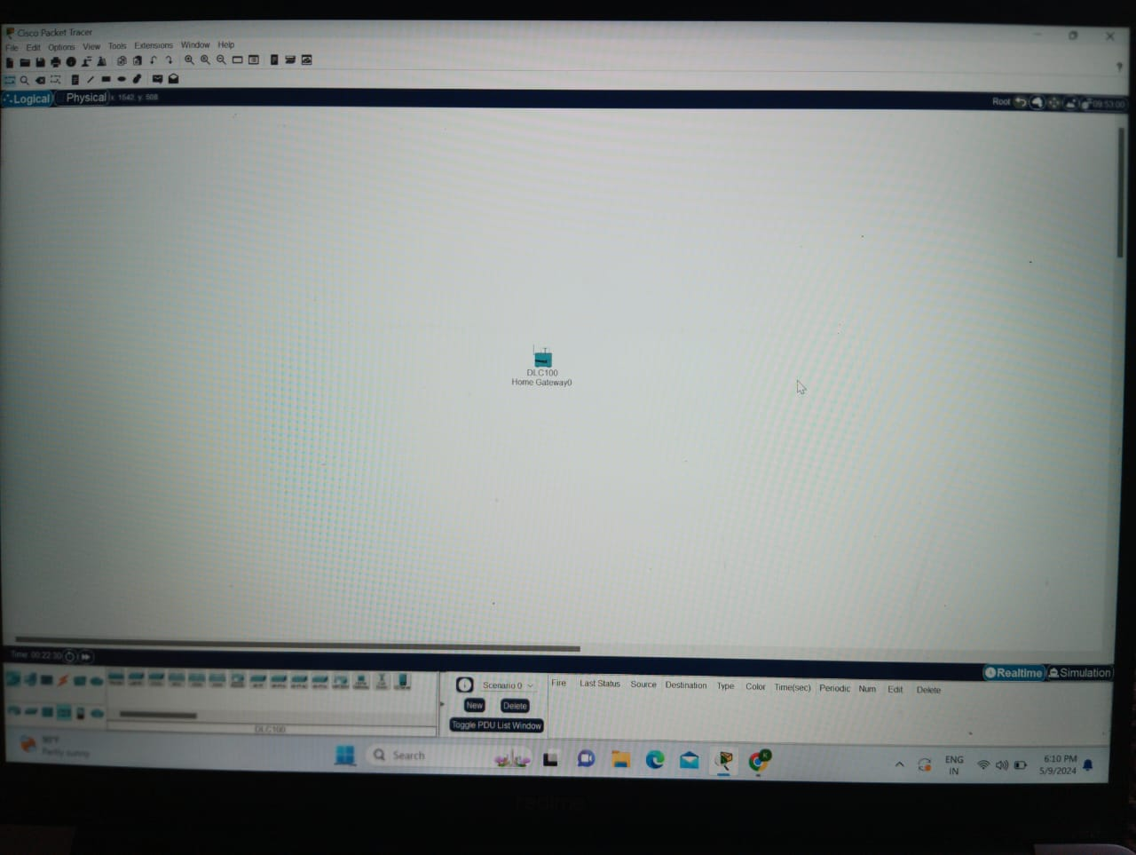

3.Select the various components in room like fan, light ,door, window and tablet.

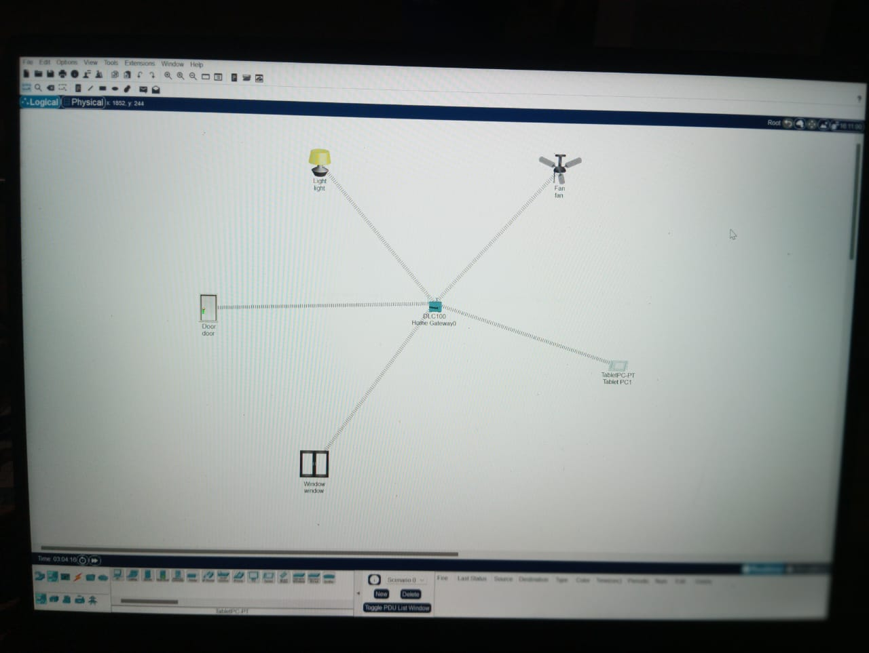

4. Double click on the Home gateway ,configuration , wireless and check and copy SSID name.

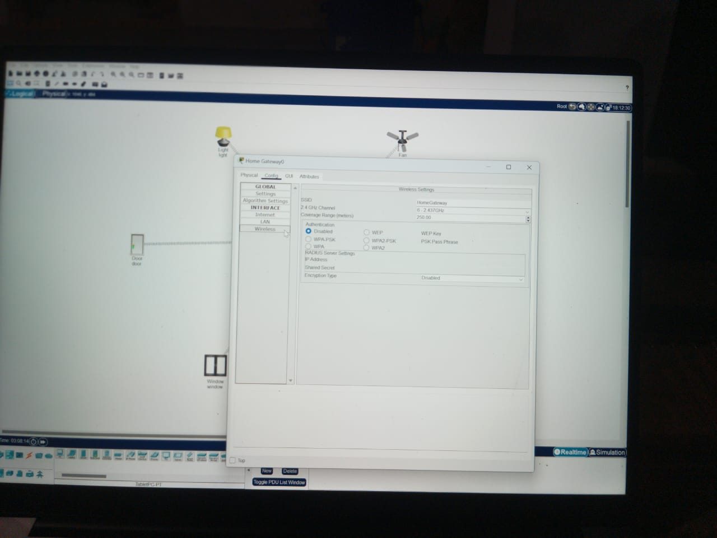

5.double click on the tablet , go to desktop, click on IOT monitor and login .

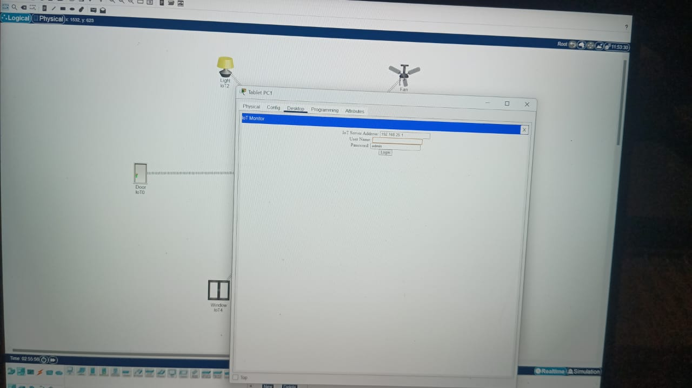

6.Click on the login .



7.Go to IOT monitor check whether all the components are added or not.

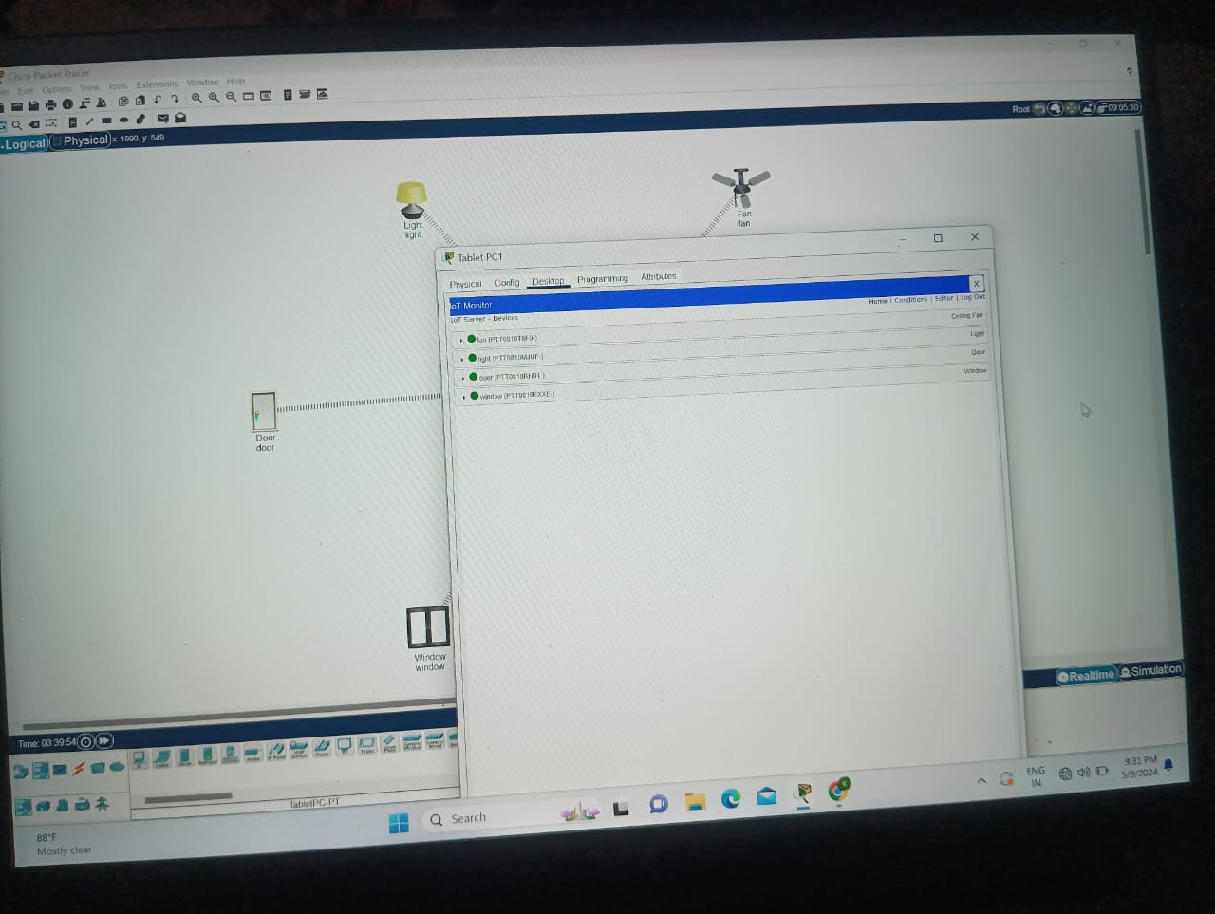

8.For daytime let us say ,we must open the door ,If door is open window must be ON ,fan must be ON and light must be OFF.

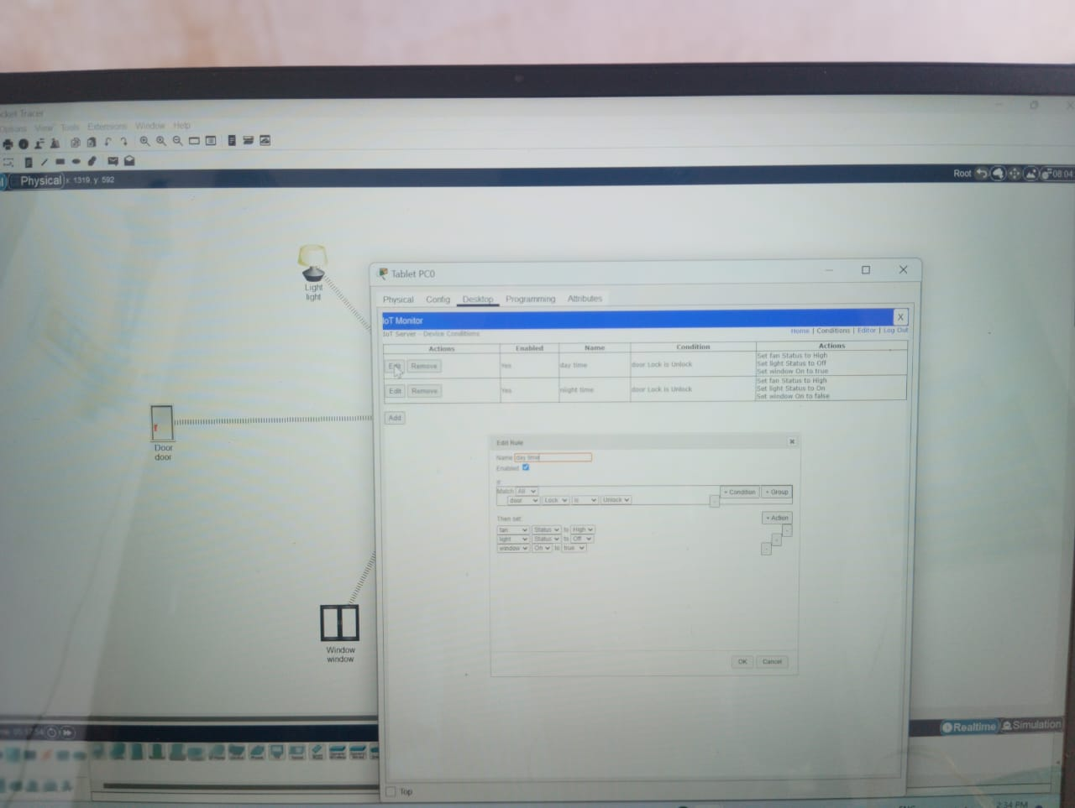

9.For night time conditions, Add given name as night time ,we must close the door .If door is closed windows must be closed, fan must be ON, light must be ON set the conditions for night time .

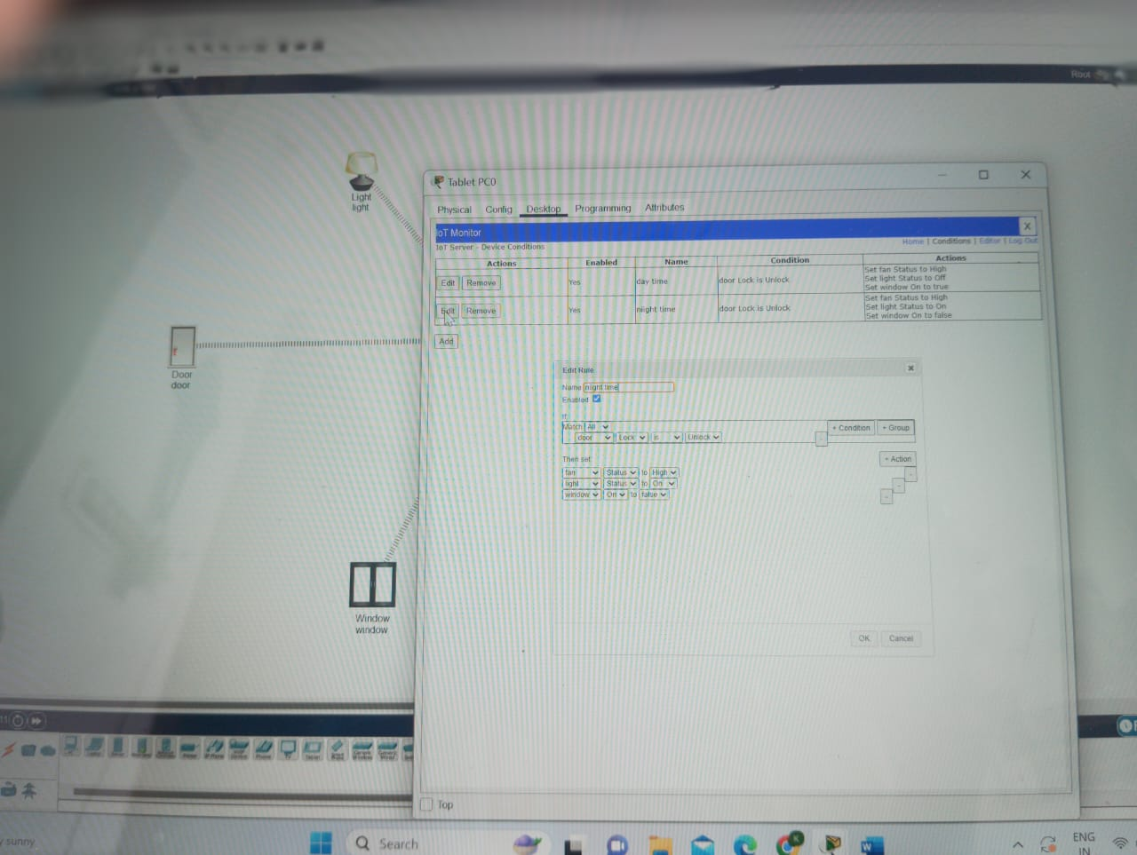

10.Then go to tablet ,desktop, IOT monitor and change the condition of door.

* Door is lock condition.

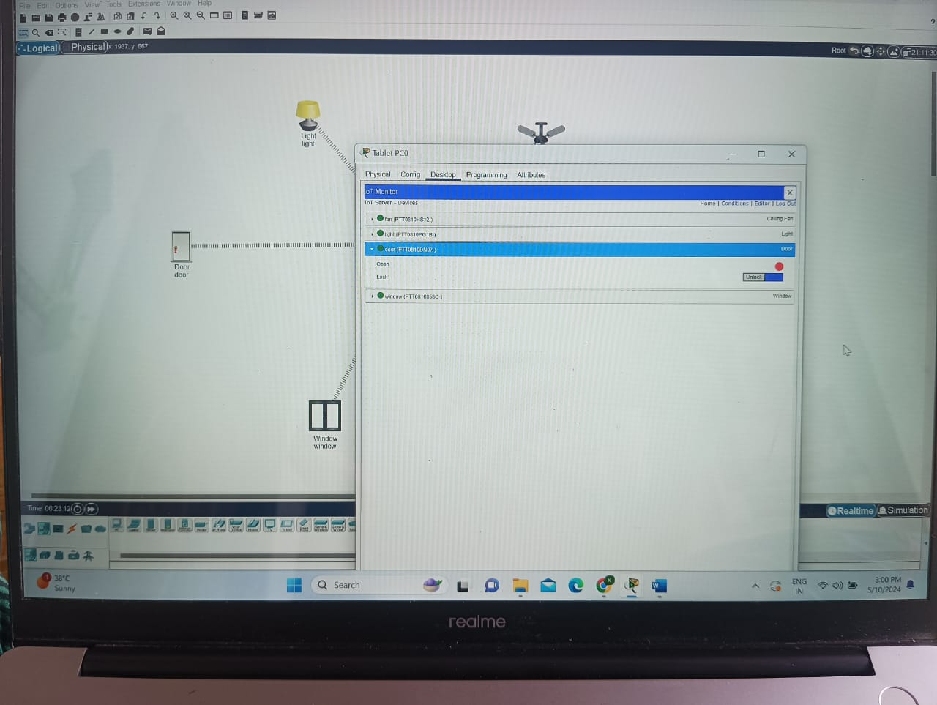

* Door is unlock condition

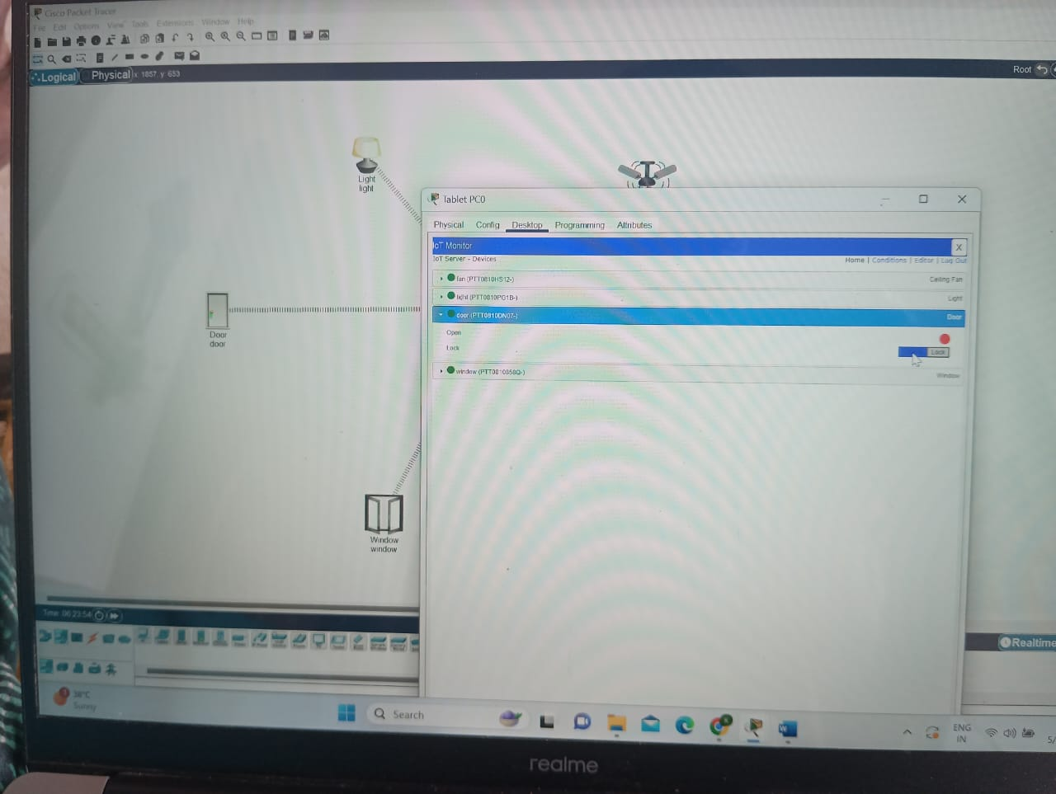

**CONCLUSION:**

Home automation offers convenience, efficiency, and security by integrating smart devices and technology into our living spaces. With features like remote access, energy management, and automated routines, it enhances comfort and simplifies daily tasks. As technology advances, the possibilities for home automation continue to expand, promising a future where our homes are more interconnected and responsive to our needs.

VIDEO LINK:

https://www.mediafire.com/file/0um0evl9o6qefg7/VID_20240509_215817.mp4/file

**LICENSE PLATE RECOGNITION SYSTEM**

**STATEMENT:**

Providing a process flow for license plate recognition system for a IT park , where the safety team needs to monitor the number plate.

**FLOWCHART:**

